BCT Assignment 4
Neeti Kurulkar
Smart Contract for Student Data

Code:

// SPDX-License-Identifier: MIT
pragma solidity ^0.8.0;

contract StudentData {
// Structure for Student
struct Student {
uint id;
string name;
uint age;
string course;
}

// Array to store students
Student[] public students;

// Mapping to track uniqueness of student IDs
mapping(uint => bool) private studentExists;

// Add a student
function addStudent(uint _id, string memory _name, uint _age, string memory _course) public {
require(!studentExists[_id], "Student ID already exists.");
students.push(Student(_id, _name, _age, _course));
studentExists[_id] = true;
}

// Get student by array index
function getStudent(uint index) public view returns (uint, string memory, uint, string memory) {
require(index < students.length, "Invalid index.");
Student memory student = students[index];
return (student.id, student.name, student.age, student.course);
}

// Get total number of students
function getStudentCount() public view returns (uint) {
return students.length;
}

// Fallback function (when wrong data/call is sent)
fallback() external payable {
revert("Fallback called - function does not exist.");
}

// Receive function (when plain ETH is sent)
receive() external payable {
// ETH is accepted silently
}
}

Output:

- Upload Code on Remix IDE

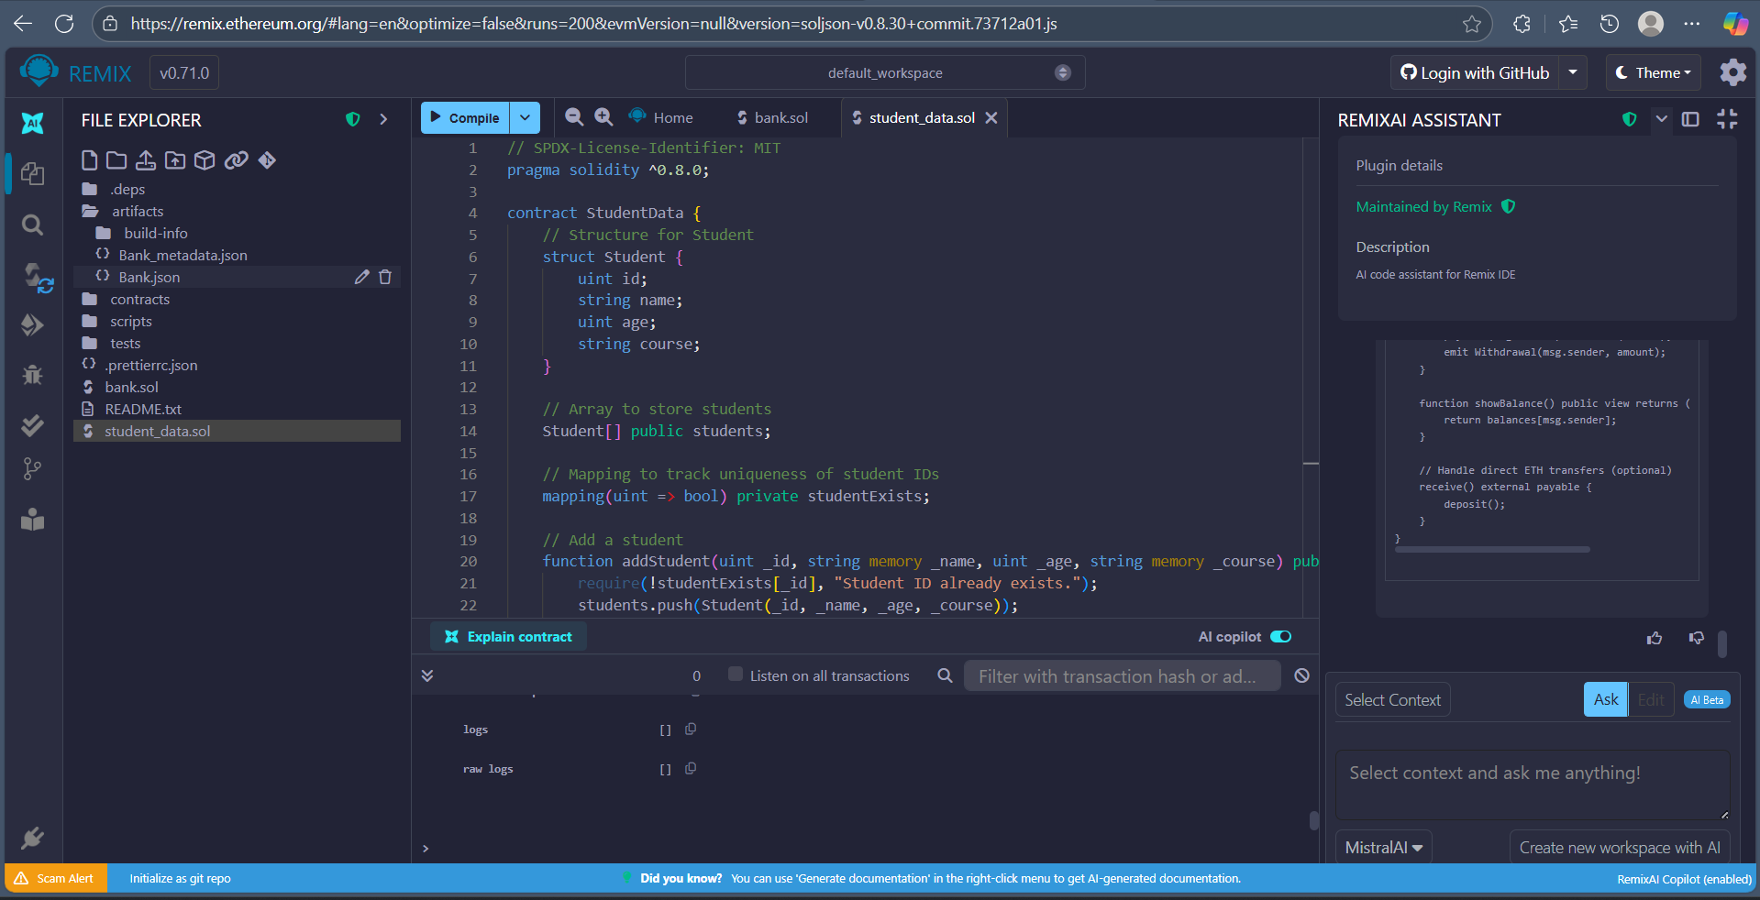

- Deploy Contract

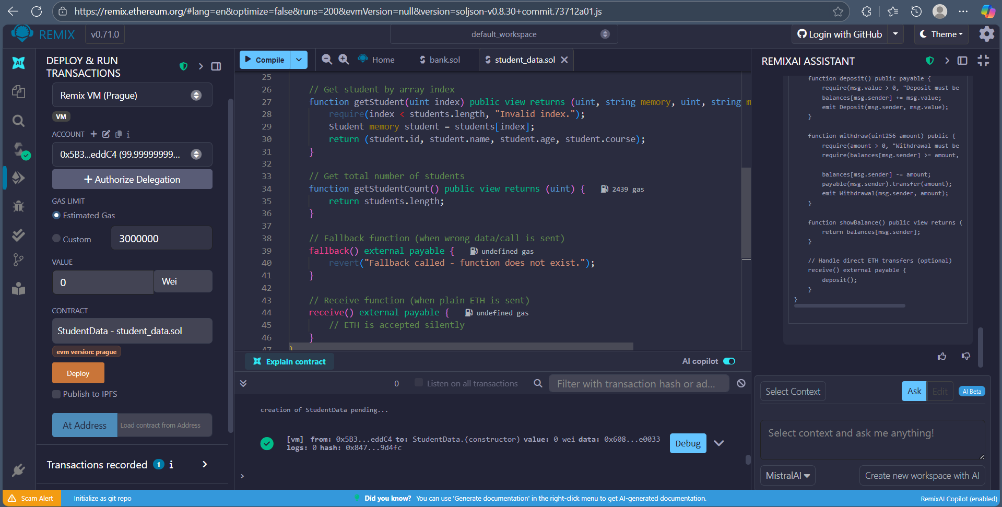

- Add Students
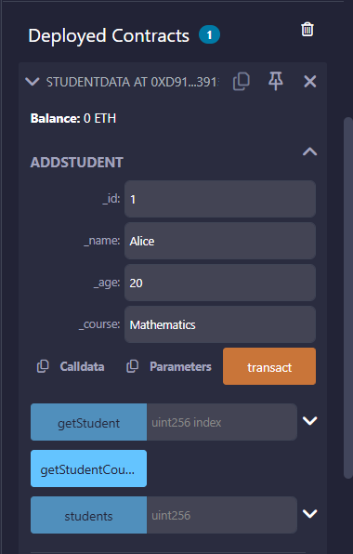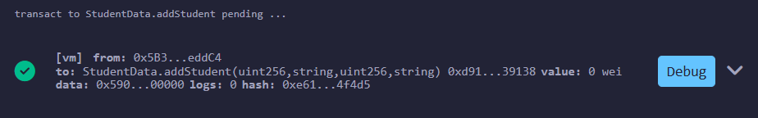

- Get Student
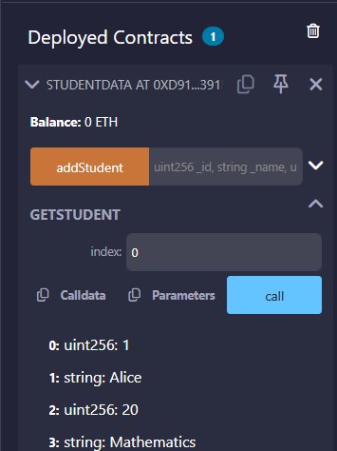

- Get Student Count

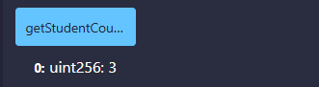

- Observe Transactions

